Date : 29-Feb-2024
Owner : Griha Council
Developed by : PaloAltoSoft Private Limited
Griha Desktop tool version 1 for coordinator to fill site visit report for SvaGriha panel
To use this tool, download it from https://grihadesktoptool.paloalto-soft.com/

Tool can be used in offline mode. First time user will need to save credentials.
1> Set App password
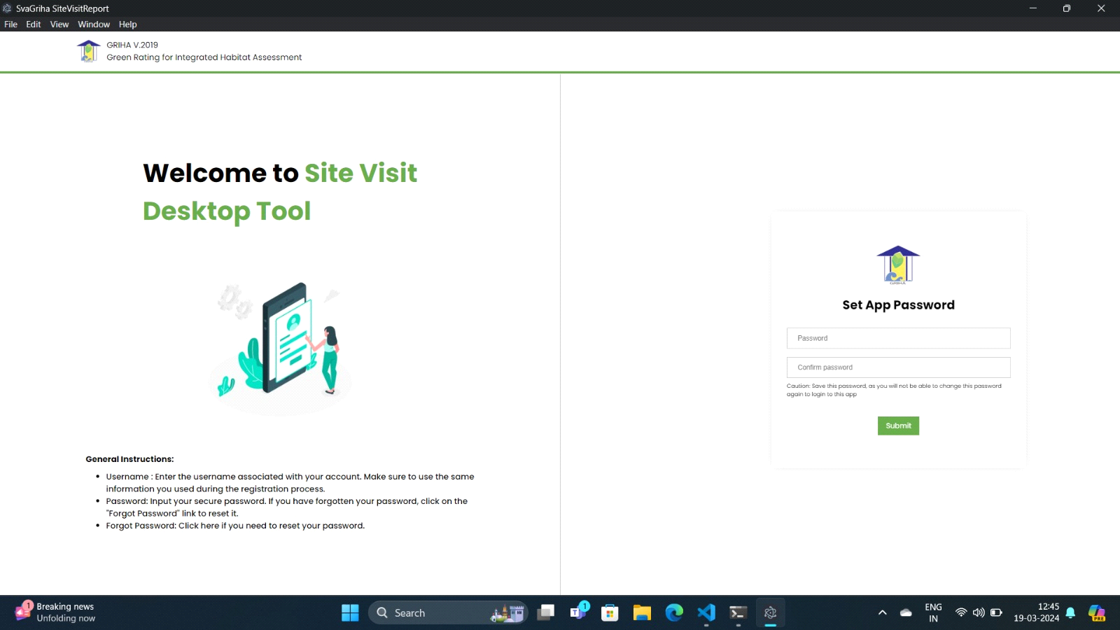
a) Remember this password to use this tool in future.
b) If you forget this password later, you can always reset the app password.

2> Server Details:
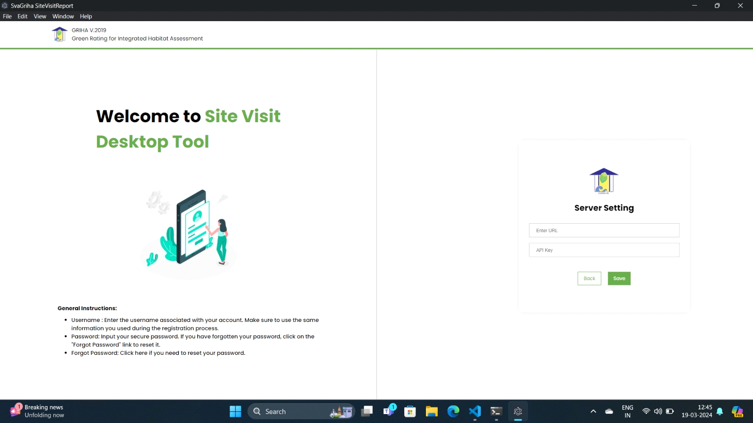

Please enter following details to connect to server in Server Settings
- grihaapi.grihaindia.org
- APIKey : Request from Griha IT Admin or alternatively contact to Mr. Ahmad.
3> Login Credentials
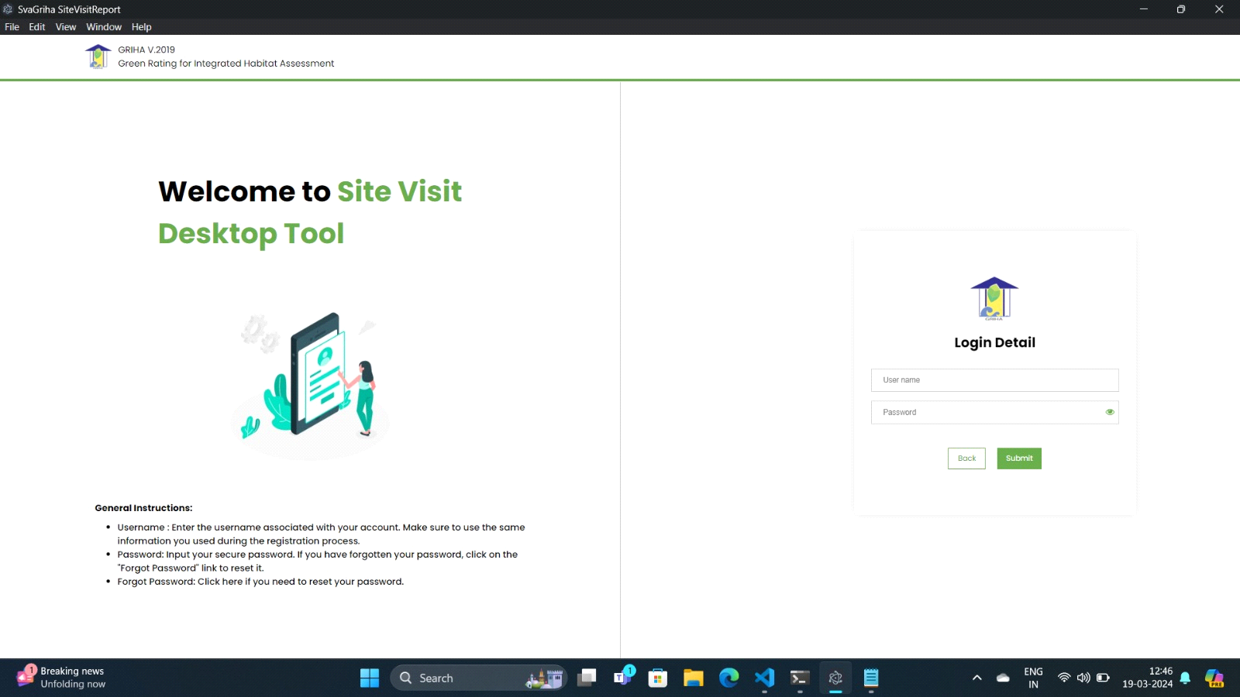
a) Login with Griha Coordinator credentials

In case you face any difficulty in using this tool, please contact Griha IT Admin.
Desktop Tool - developed for Griha Council for SvaGriha Ratings
-Developed by PaloAltoSoft Private Limited.
- Do not distribute the tool for external usage.

